PARENT-TEACHER COMMUNICATION
@CREATIVITY THINK (9483175986/7019689991)

ABSTRACT:
Parent-Teacher Communication is a web-based platform designed to enhance interaction between parents, teachers, and school administrators. The system supports real-time messaging, announcements, event notifications, calendar synchronization, and dashboard analytics. It enables parents to stay updated on school activities, while teachers and admins can share information, monitor communication, and ensure smooth coordination. Developed using Django and Django Rest Framework on the backend and React with Redux and Socket.io on the frontend, the platform ensures secure data exchange, scalable communication, and a user-friendly interface suitable for schools, preschools, and coaching institutions..

INTRODUCTION OF THE PROJECT:
Communication between parents and educators plays a crucial role in student development. However, traditional communication channels such as handwritten notes, phone calls, or scattered messaging apps often create inconsistencies and miscommunication. Schools need a structured, centralized, and secure system to manage announcements, academic updates, and event coordination. The Parent-Teacher Communication system fulfills this need by providing an integrated communication platform with real-time messaging, event scheduling, announcements, and analytics dashboards. The solution enhances transparency, fosters engagement, and streamlines institutional communication..

PROJECT OBJECTIVES:

• Provide a secure communication system for parents and teachers
• Enable real-time messaging using Socket.io
• Allow admins and teachers to publish announcements and events
• Offer calendar synchronization for upcoming school activities
• Generate dashboard statistics for communication insights
• Improve parent engagement through timely updates
• Ensure scalable and secure backend APIs
• Support multi-role access with moderated communication

PROBLEM OF THE STATEMENT:
Schools face challenges in maintaining consistent communication with parents. Traditional methods are slow, unreliable, and lack centralized tracking. Messaging apps pose privacy concerns and do not offer institutional-level controls. Parents often miss important updates due to scattered channels. The Parent-Teacher Communication system addresses these issues by providing a dedicated, secure, real-time, and school-managed communication platform with structured roles, announcements, events, and analytics..

MOTIVATION OF THE PROJECT:
• To digitalize communication in schools
• To ensure timely and reliable information flow
• To provide real-time interaction between parents and teachers
• To reduce dependency on informal or unsecured apps
• To centralize announcements, events, and calendars
• To improve transparency and parental involvement
• To empower admins with communication analytics

BLOCK DAIGRAM OF PROJECT:

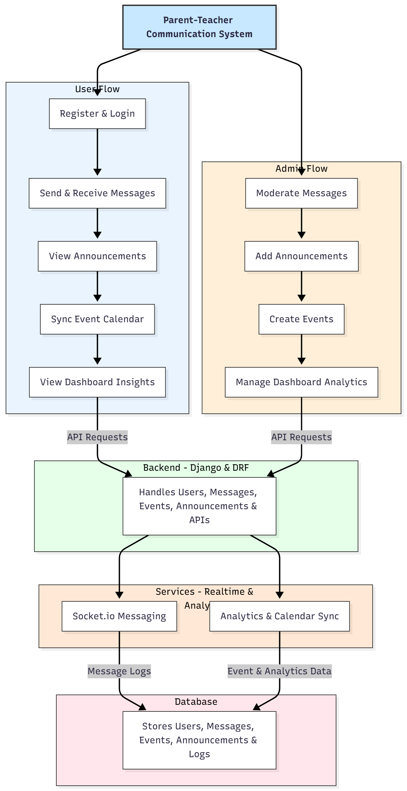

WORKING OF THE PROJECT:
The system begins with user registration and role assignment. Parents and teachers log in to send or receive messages, which are processed in real time using Socket.io services. Administrators can publish announcements and schedule events that reflect instantly on the user dashboards and synced calendars. Every message and event is securely stored in the database. The backend manages authentication, message routing, announcements, events, and analytics processing. The dashboard visualizes communication statistics, unread messages, event participation, and parent engagement levels. This ensures seamless interaction, transparency, and efficient communication management..

SOFTWARE REQUIREMENT:
- Backend:
  - Python 3.x
  - Django
  - Django REST Framework
  - SQLite/PostgreSQL
- Frontend:
  - Node.js and npm
  - React.js
  - Axios
- Development Tools:
  - Visual Studio Code
  - Postman (for testing APIs)
  - Git/GitHub (for version control)
- Server/Deployment (Optional):
  - Gunicorn, Nginx, or Heroku/AWS for hosting

ADVANTAGES OF THE PROJECT:

• Real-time messaging between parents and teachers
• Centralized announcements and event updates
• Calendar synchronization for upcoming activities
• Role-based communication and admin moderation
• Improved transparency and parental involvement
• Lightweight, responsive, and scalable platform
• Data-driven dashboard analytics

APPLICATIONS OF THE PROJECT:
• Schools
• Preschools
• Coaching centers
• Educational institutions of all levels
• Parent engagement systems

REFERENCES:

- Django REST Framework Documentation — Django Software Foundation. Django Documentation. Available: https://docs.djangoproject.com/
- Django REST Framework. DRF Documentation. Available: https://www.django-rest-framework.org/
- React. React Official Documentation. Available: https://reactjs.org/docs/getting-started.html
- Redux. Redux Documentation. Available: https://redux.js.org/introduction/getting-started
- PostgreSQL Global Development Group. PostgreSQL Documentation. Available: https://www.postgresql.org/docs/
- MySQL. MySQL Reference Manual. Available: https://dev.mysql.com/doc/
- Git. Git Documentation. Available: https://git-scm.com/doc
- Node.js. Node.js Documentation. Available: https://nodejs.org/en/docs/
- Axios. Axios Documentation. Available: https://axios-http.com/docs/intro
- Socket.io Documentation – https://socket.io/docs/

